

Essay
Time-25 minutes

Turn to page 2 of your answer sheet to write your ESSAY.

The essay gives you an opportunity to show how effectively you can develop and express ideas. You should, therefore, take care to develop your point of view, present your ideas logically and clearly, and use language precisely.

Your essay must be written on the lines provided on your answer sheet—you will receive no other paper on which to write. You will have enough space if you write on every line, avoid wide margins, and keep your handwriting to a reasonable size. Remember that people who are not familiar with your handwriting will read what you write. Try to write or print so that what you are writing is legible to those readers.
You have twenty-five minutes to write an essay on the topic assigned below.

Important Reminders:
- A pencil is required for the essay. An essay written in ink will receive a score of zero
- Do not write the essay in your text book. You will receive credit only for what you write on your answer sheet
- An off-topic essay will receive a score of zero.

Sentence Completion Instructions

Each sentence below has one or two blanks, each blank indicating that something has been omitted. Beneath the sentence are five words or sets of words labeled A through E. Choose the word or set of words that, when inserted in the sentence, best fits the meaning of the sentence as a whole.

Example:
 | Medieval kingdoms did not become constitutional republics overnight; on the contrary, the change was ----.
 | (A) | unpopular
 | (B) | unexpected
 | (C) | advantageous
 | (D) | sufficient
 | (E) | gradual
Correct Answer: E Ⓐ Ⓑ Ⓒ Ⓓ ●
Reading Passages
The passages below are followed by questions based on their content; questions following a pair of related passages may also be based on the relationship between the paired passages. Answer the questions on the basis of what is stated or implied in the passages and in any introductory material that may be provided.

Sentence Correctness

The following sentences test correctness and effectiveness of expression.
Part of the sentence or the entire sentence is underlined; beneath each sentence are five ways of phrasing the underlined material. Choice A repeats the original phrasing; the other four choices are different. If you think the original phrasing produces a better sentence than any of the alternatives, select choice A; if not, select one of the other choices.

In making your selection, follow the requirements of standard written English; that is, pay attention to grammar, choice of words, sentence construction, and punctuation. Your selection should result in the most effective sentence—clear and precise, without awkwardness or ambiguity.

EXAMPLE:

Laura Ingalls Wilder published her first book and she was sixty-five years old then.
(A) and she was sixty-five years old then
(B) when she was sixty-five
(C) at the age sixty-five years old
(D) upon the reaching of sixty-five years
(E) at the time when she was sixty-five
Correct Answer: B Ⓐ ● Ⓒ Ⓓ Ⓔ

Identifying Sentence Errors
The following sentences test your ability to recognize grammar and usage errors. Each sentence contains either a single error or no error at all. No sentence contains more than one error. The error, if there is one, is underlined and lettered. If the sentence contains an error, select the one underlined part that must be changed to make the sentence correct. If the sentence is correct, select choice E. In choosing answers, follow the requirements of standard written English.

The other delegates and him immediately
A B C
Accepted the resolution drafted by the neutral states. No error
D E
Ⓐ ● Ⓒ Ⓓ Ⓔ
Improving sentences in passages
The following passage is an early draft of an essay. Some parts of the passage need to be rewritten.

Read the passage and select the best answers for the questions that follow. Some questions are about particular sentences or parts of sentences and ask you to improve sentence structure or word choice. Other questions ask you to consider organization and development. In choosing answers, follow the requirements of standard written English.

Math Directions
For this section, solve each problem and decide which is the best of the choices given. Fill in the corresponding circle on the answer sheet. You may use any available space for scratchwork.

- The use of a calculator is permitted
- All numbers used are real numbers
- Figures that accompany problems in this test are intended to provide information useful in solving the problems. They are drawn as accurately as possible EXCEPT when it is stated in a specific problem that the figure is not drawn to scale. All figures lie in a plane unless otherwise indicated.
- Unless otherwise specified, the domain of any function f is assumed to be the set of all real numbers for x for which f(x) is a real number.

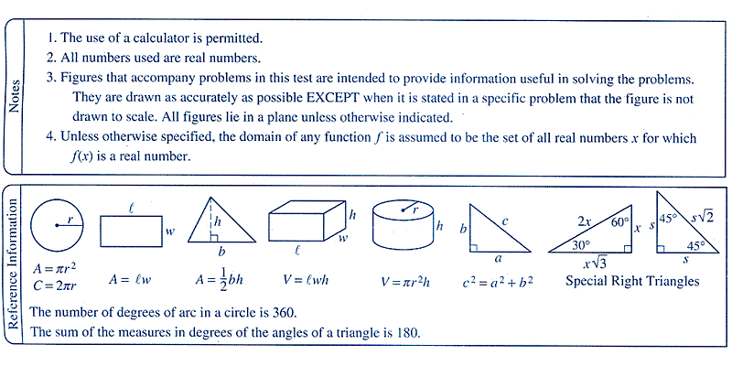
Below is how the directions look on the test with the reference information right below.

Student Response Questions

S